A Day Assignment: The Alphabet Project
This week were are going to start a 5 week project- we will be completing different parts of the Alphabet project each week so that it isn’t overwhelming. You will be required to photograph the letters of the alphabet and send the letters for that week to me on a work document. You can use your phone or camera (whatever is available). If you prefer to collage them together in a pic collage like you can on Instagram you are allowed to submit it that way as well. Email me: aogle87@gmail.com or you can text me: 856-418-0477.
This week (4/27-5/1) the letters you need to photograph and send me are: A B C D E F (the first 5 letters of the alphabet). Get creative and look around your home or even the outside environment to help you. It is all about how you crop the picture. Below are some examples of what you can look for. These were all found in my home or outside in my yard. The left pictures will be what I saw and used and the right picture will be how I cropped it to make the letter.

Letter “L” – I adjusted my angle and cropped the picture. I also brightened the image a bit to enhance the color.
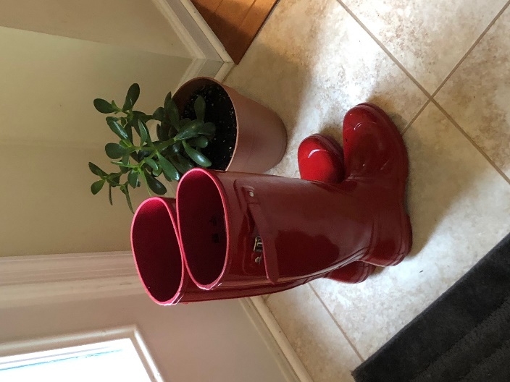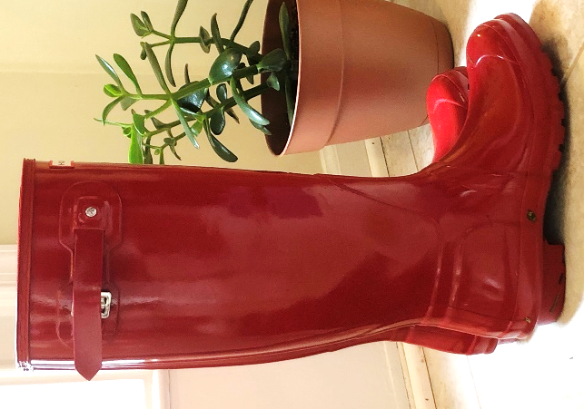
There are more exmaples on the following pages so keep looking!!

Letter Q- for this one I rotated and cropped the picture around to make it make a capital “Q”. I also changed it to black and white to get rid of any distractions of the back wall color.
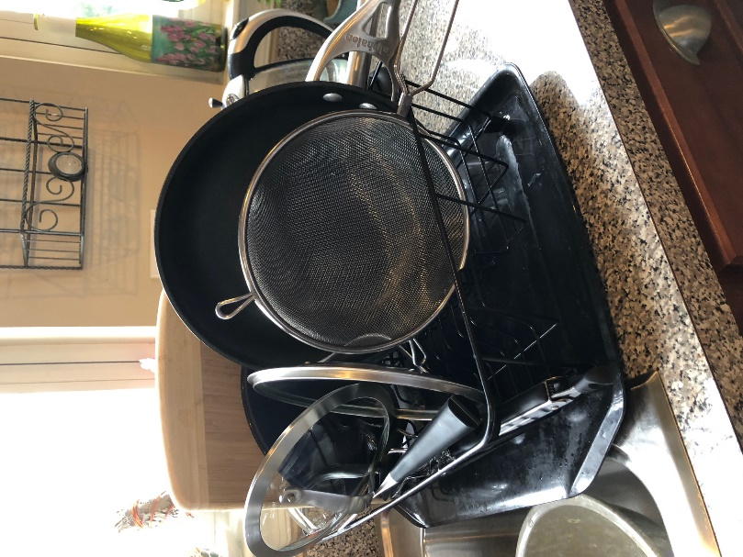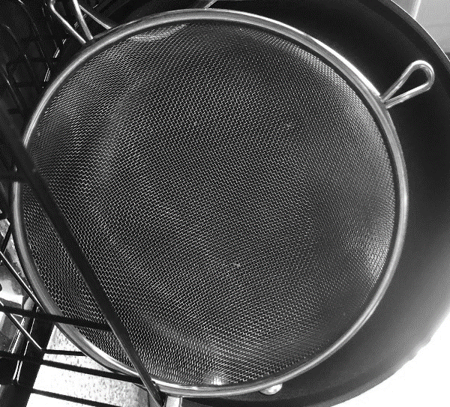

Letter G- This is a hanging piece on my kitchen wall. I cropped the image to focus on the letter “G”
